Exercise#1

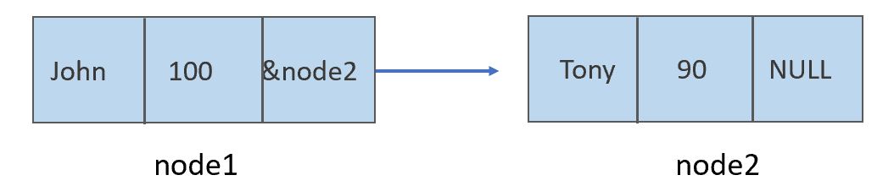

Exercise#2

Q: What are the advantages and disadvantages of linked list

over array?

A:

* Advantages:

1. One of the advantages of linked list is no memory will be wasted. Linked list is dynamic data structure, it can be flexibly changed according to needs while array may waste a lot of memory.

2. Inserting and deleting nodes is very easy, and it is not need to move elements.

* Disadvantage

1. In the linked list, each node contains a pointer, so it requires additional memory for the pointers.
2. The time required to access the node is too long, because if we want to visit a node somewhere, we must traverse all the nodes before it, so it cannot be as easy as array to travel.